Firstname1 SURNAME1, Firstname2 SURNAME2 (10 pt bold, italic, with diacritics )

INSTRUCTIONS FOR AUTHORS AND SAMPLE PAPER
(12 PT BOLD, CAPITAL LETTERS, CENTERED)

¶ (12 pt)
Abstract: Abstract of 50-120 words (10 pt, italic). The file with the instructions is available on the SORGING web page (http://www.sorging.ro/ro/articole/instructiuni-de-redactare). Use the file as a template for writing your paper.
¶ (10 pt)
Key words: List 5-8 keywords. (10 pt, italic).
¶ (10 pt)
¶ (10 pt)

1. INTRODUCTION (10 PT, CAPITALS, BOLD)
¶ (10pt)
(10 pt, normal) The paper has to be written in English U.K.. (http://www.tysto.com/uk-us-spelling-list.html) Its contents should be structured in the following way: problem description, application field, research stages, methods used, results, further research, conclusions, and references.
The paper has to offer the answers for the following questions: description of the problem, what is done by
other people, what the authors did, what is new, what is
my contribution?
¶ (10pt)
2. INFORMATION
¶ (10pt)
2.1 Page layout (10 pt, bold)
- Use A4 format (210 x 297 mm)
- Margins: Top - 2,5 cm, Bottom, Left and Right - 2 cm each.
- Header - 1,25 cm; Footer - 1,25 cm.
- 2 columns, column distance 7 mm.
- The text should be written on one side of the page
only.
- The paper has to be written in WINWORD format.
- Paragraphs: alignment - justified, line spacing –
single.
- Fonts
- Font style: Times New Romans.
- Font size for:
paper title: 12 pt bold, capital letters;
author's name(s): 10 pt bold;
key words: 10 pt, italic;
chapter titles: 10 pt bold, capital letters;
subtitles: 10 pt bold, numbered, left
aligned, upper and lower case;
text: 10 pt.; regular,
- Tab stop position: 5 mm.
- The paper must have between 4 - 8 A4 pages. In exceptional cases accept a maximum of 16 pages. Required number of pages must be an even number and the last page must be completed at a rate of at least 80%.
- Print with 300 dpi or more.
- No heading at the bottom of a column, without minimum 2 rows of subsequent text (else, push the headings up to the top of the next column).

- Use the maximum area for text.
¶ (10 pt)
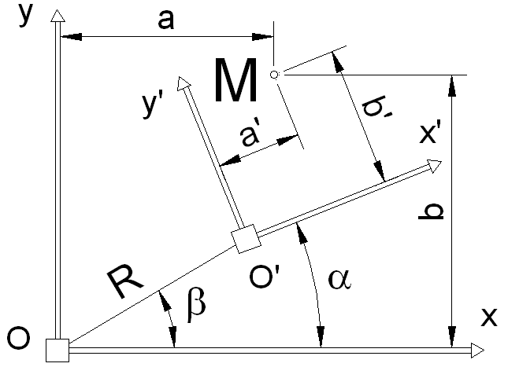
¶ (10 pt)
Figure 13 Title of figure, centre aligned.
¶ (10pt)
3. FIGURES
¶ (10pt)
Figures have to be made in high quality, which is suitable for reproduction and print. Don't include photos
or colour prints. Place figures (centre aligned) at the top or bottom of a column wherever possible, as close as possible to their first reference in the paper. Figures larger than the column width can be placed on the whole
width of the page but only at the beginning or end of page. The text inside the figures and notations has to be 10 p. Figure number - 9 pt, bold, centred aligned, followed by figure title- 9 pt, regular. The figures must be referred in text as follows: Figure 1.
¶ (10pt)
3.1 Language, Stile Spelling
- Use common technical terms.
- Use concise and intelligible phrases.
- Use Spelling.
- The editor’s requirements impose to consult an English translator or professor.
¶ (10pt)
Table 1
Title of table - center aligned and justified, 9 point, bold.
Column 1 | Column 2 | Column 3 | Column 4
Row 1 | 4,83 | 3,34 | 4,34
Row 2 | 4.23 | 5,23 | 4,12
¶ (10pt)
3.3 Mail
Protect your paper and especially your disk from damages during mail
¶ (10pt)
4. TABLES
¶ (10pt)
Tables should be placed as close as possible to their first reference. Table number - 9 pt, italic, right aligned, table title- 9 pt, bold, centred.
¶ (10pt)
5. EQUATIONS
¶ (10pt)
Equations will be centred and numbered consecutively (right aligned). Use the equation editor only.
¶ (10pt)
$X_{s}=k⋅u⋅\text{sin}α_{0}−\left(R_{R}+k⋅m⋅\frac{π}{4}\right)$. (1)
$Y_{s}=k⋅u⋅\text{cos}α_{0}−\left(R_{R}+k⋅m⋅\frac{π}{6}\right)$ (2)
$Z_{s}=λ⋅k⋅u⋅\text{sin}α_{0}\text{cos}α_{0}$ (3)
¶ (10pt)
Legend, font, Italic, pt.
¶ (10pt)
6. REFERRING
¶ (10pt)
When a publication is mentioned in the text, enclose its number in brackets (for example [1] or [3], [5]).
¶ (10pt)
¶ (10pt)
7. CONCLUSIONS
¶ (10pt)
We are sure that if you read the instructions carefully and prepare the paper exactly according to the instructions, you will have the satisfaction of a good published paper.
¶ (10pt)
ACKNOWLEDGEMENT
¶ (10pt)
Is not mandatory.

¶ (10pt)
REFERENCES
¶ (10pt)
References have to include at least 2 items, their numbers in brackets, subsequent lines indented (see examples). All references will be directly cited in the body of the paper text.
[1] Name11, S11., Name12, S12. (2002). Name of Book in Italics, in English (in original language), Publisher, ISBN, Place of Publication.
[2] Name21, S21., (1999). Title of conference paper, in English (in original language), Proceedings of yyy yyy, Editor Name (Ed.), pp. 14-17, ISBN, conference location, month and year, Publisher, City.
[3] Name31, S31., Name32, S32. (1997). Name of paper. Name of Journal, Vol., No., (month and year of the edition) page numbers (first-last), ISSN.
[4] Name41, S41., Name42, S42. (2001). Name of paper, In: Name of Book, Name(s) of Editor(s), (Ed.), page numbers (first-last), Publisher, ISBN, Place of publication.
[5] Name51, S51., Name52, S52. (2000). Name of Paper, available at: http://www.exact-address-of-site Accessed: YYYY-MM-DD.
¶ (10pt)
¶ (10pt)
Author(s):
¶ (10pt)
Title (bold). Firstname1 SURNAME1 (bold), Affiliation, Name of Department, E-mail.
Prof. Ioanus ACADEMICUS, University of Cambridge, Department of Graphics and Design, E-mail: eu_academicus@yahoo.com

